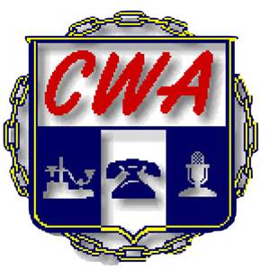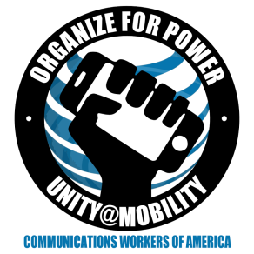
CWA/ AT&T Mobility National Bargained Benefit Bargaining
Report #4 March 25, 2016

The Bargaining Committees met yesterday via phone conference in a morning session with AT&T Executive Director of Benefits and CWA Researchers Louise Novotny and Dan Reynolds joining the meeting.
Making the insurance more affordable is important to CWA and our members at Mobility. In analyzing the data provided to CWA, it is shockingly apparent that a very high number of newer employees are declining the healthcare benefits.
CWA believes the employee cost is the reason. AT&T believes that their employee turnover is the cause of the statistic and that employees are also declining the medical benefits due to being a dependent on a family member’s healthcare.
In the afternoon session, the Company withdrew their first proposal and passed a second proposal with a high-deductible option in addition to the current plan.
We believe a fair model for determining costs for the employees would factor in wages and we will be pursuing this in upcoming bargaining sessions. CWA’s goal is to make this the last NBBP agreement and going forward bargain the wages and benefits together.
We made requests for several plan comparisons today and will be using the information to counter the Company proposal. We will continue to meet via phone conference next week.
In Solidarity,
The CWA 2016 Mobility NBBP Bargaining Committee
Kelvin Banks, D3; Luis Benitez, D3 Puerto Rico; Holly Sorey, D4; John Richie, D6
Pat Telesco, D1

