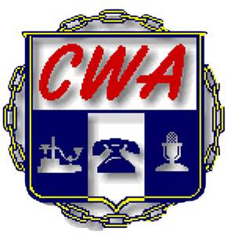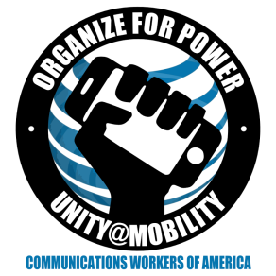
CWA/ AT&T Mobility National Bargained Benefit Bargaining
Report #2 March 3, 2016

The CWA Bargaining Committee met via phone conference this week to discuss the Company’s proposal and continues to review data from the company. We will meet as a committee and with the Company bargainers next week.
AT&T is proposing cost increases with no real improvements. Our main goals as we work toward an agreement are to make the plan more affordable, and to make this the last time we bargain healthcare separately from the regional Labor Agreement that CWA has with AT&T.
The fact that the NBBP is bargained separately from the Labor Agreements hinders us from balancing the costs of the benefit against the wages we earn and bargaining both together will give us more leverage.
Support the NBBP Bargaining Committee and tell the boss you need healthcare you can afford!
In Solidarity,

The CWA 2016 Mobility NBBP Bargaining Committee
Kelvin Banks, D3; Luis Benitez, D3 Puerto Rico; Holly Sorey, D4; John Richie, D6
Pat Telesco, D1

