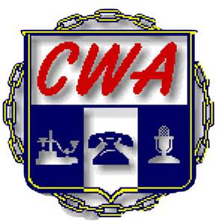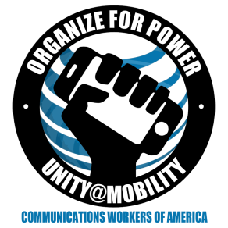
CWA/ AT&T Mobility National Bargained Benefit Bargaining
Report #5 April 1, 2016
As the Company and Union Bargaining Committees prepare to meet face to face in Austin, Texas next week, we remain far apart. AT&T and CWA bargainers met yesterday and today via phone conference and CWA passed our first two proposals.
The CWA is trying to mitigate the factors that drive so many employees away from being able to afford health insurance. As we said in previous reports, the number of employees who opt out of the healthcare makes it apparent that the workers at AT&T Mobility see cost as a roadblock to using the healthcare that is offered.
AT&T has said their goal for this bargaining is to increase the cost share of what employees pay for coverage. Really! This is not an April Fool’s joke.
Currently, about 30% of the bargained for employees opt out of coverage; this is over 12,600 employees! The Company has passed proposals indicating a level of future contributions for years 2018, 2019, and 2020 that are a percentage of an unknown amount. CWA needs AT&T to get real and not provide a benefit that their employees cannot afford!
We need to make this the last time the NBBP is bargained and “unwind” the National Agreement. As the Regional Labor Agreements expire, the benefits should be bargained with other components of wages and compensation, and we have proposed this.
In Solidarity,
The CWA 2016 Mobility NBBP Bargaining Committee
Kelvin Banks, D3; Luis Benitez, D3 Puerto Rico; Holly Sorey, D4; John Richie, D6
Pat Telesco, D1

