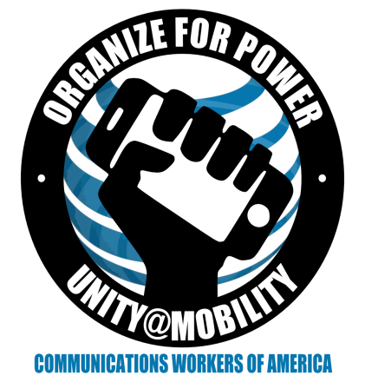 CWA/AT&T Mobility National Bargained
Benefit Plan (NBBP) 2016 Bargaining
- What is the NBBP?
Back in 2004, when AT&T Mobility was Cingular Wireless, the CWA made an agreement with AT&T that brought all the Cingular employees together under one bargained benefit plan.
For the first time, employees covered by the contracts CWA had with Cingular were under one benefit agreement that was bargained separately and off cycle from the contracts. When agreement was not reached, CWA was forced to let an arbitrator decide what our members should have for healthcare!
This solved issues CWA faced at the time, but has not worked out good for us since then. The NBBP has been renegotiated in 2008, 2012 and now we hope we are renegotiating it for the last time. We cannot let an arbitrator decide our fate again!
- Our Bargaining goals:
  - “Unwind” the NBBP Agreement and put the healthcare benefit bargaining back into the contracts so we can balance the costs with our wages, and have more leverage to make plans more affordable.
  - Bargain benefits through 2020 now, and when the regional contracts expire, the benefits for 2021 and beyond will be part of each agreement.
  - To maintain the level of benefits while making the healthcare more affordable by offering more options.

- How will be achieve this?
  - We will be successful with your help. Let the company know that in the next round you want to bargain your benefits with your contract and wage package!
  - Tell the boss you need healthcare you can afford!

